**SETTING UP ANGULAR JS ENVIRONMENT FOR SALESFORCE.COM**

**Pre-Requisite**:

* Text Editor (Prefered Submile Text3)
* Node.js
* Npm
* Grunt
* Bower
* MavensMate

**Step 1:** Download and install Sublime Text3

Find download link from below link.

<http://www.sublimetext.com/>

After downloading run the installer file.

**Step 2:** Download and Install Node.js

Download Node.js 4.4.2 LTS or Node.js v5.10.1 from below link.  
 <https://nodejs.org/en/>

After downloading run the installer file.

Follow the prompts in the installer.

To test whether node is installed type

*node –v* and check the version .



**Step 3**: Create Project folder for angular JS project

Create a folder with any name at any location say C:\Angular_Project.

**Step 4** : Install NPM inside the project folder

In command Prompt open the project directory  
 *cd C:\Angular_Project*

On command prompt run

*npm install*

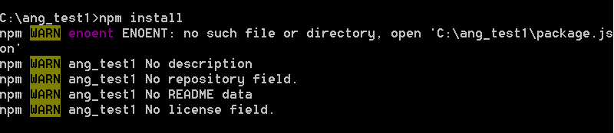

To check the version of NPM type

*npm –version*



After installing npm check for the presence of node_modules folder in the project directory.

**Step 5:**

Copy the following file from Github respository and paste them on our project folder

<https://github.com/kushagradesai/Angular_Mandatory_Files.git>

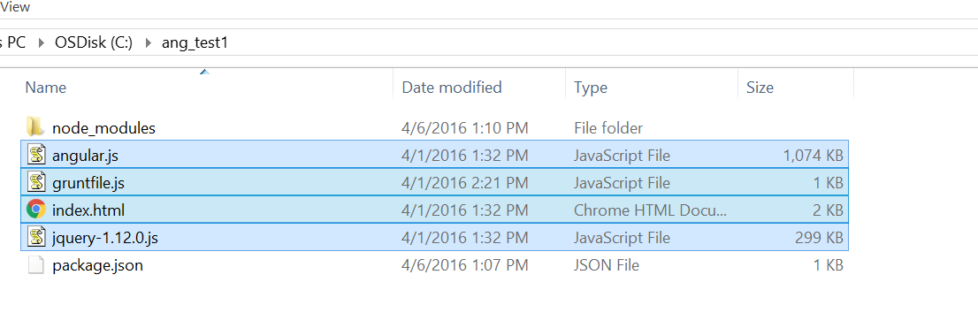Those highlighted should be pulled and pasted in the project folder.

**Step 6** : Initialize npm to create package.json

On command prompt type

*npm init*

C:\ang_test1>npm init

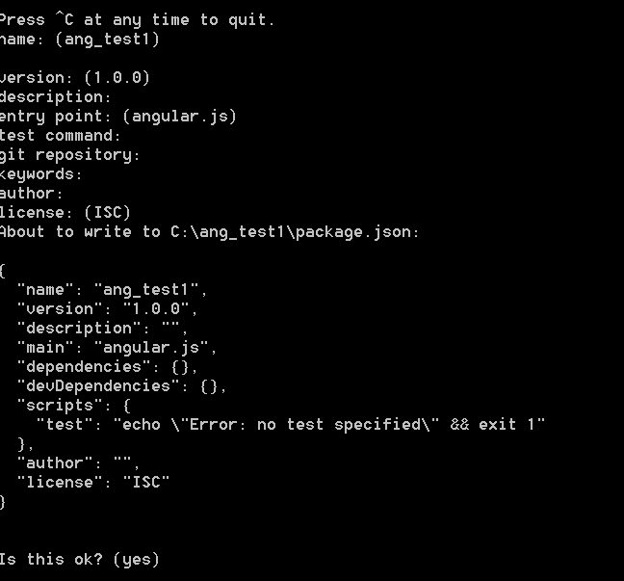

When prompted for details hit enter for all.

**Step 7**: Install Grunt

On command prompt type

*npm install grunt --save-dev*

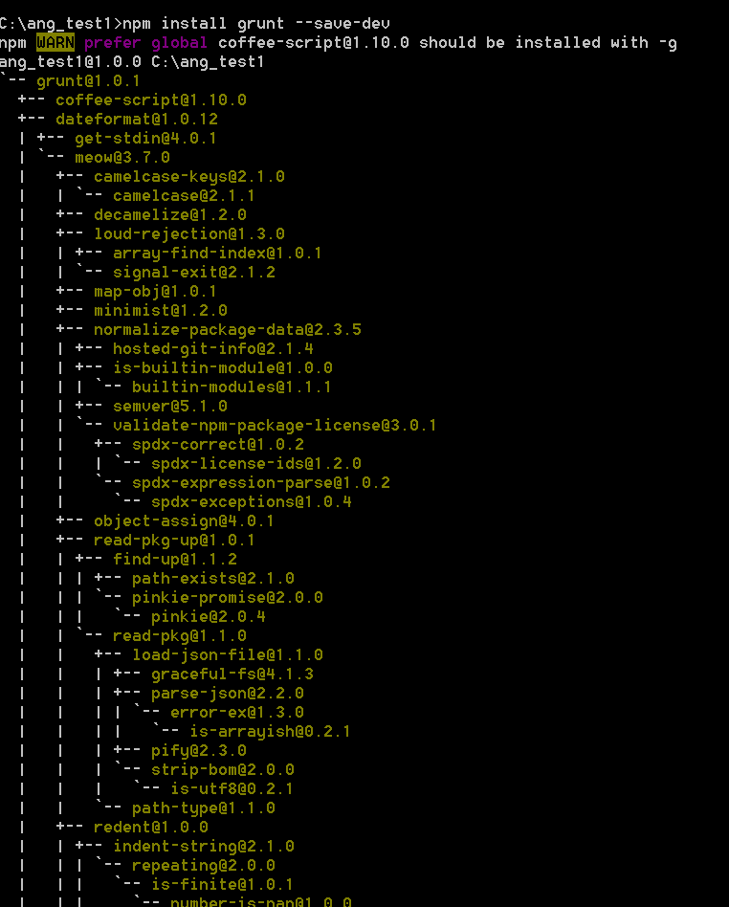

Check for grunt under devDependencies in package.json file .

devDependencies": {

"grunt": "^1.0.1",

On the command prompt type

*npm install grunt-contrib-concat --save-dev*

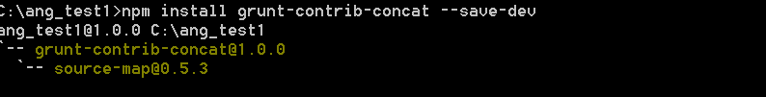

Check for grunt-contrib-concat under devDependencies in Package.json

"devDependencies": {

"grunt": "^1.0.1",

"grunt-contrib-concat": "^1.0.0",

On the command prompt type

*npm install grunt-contrib-jshint --save-dev*

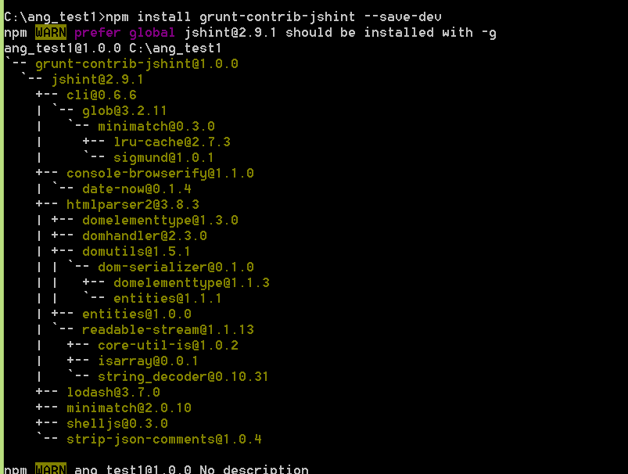

Check for grunt-contrib-jshint under devDependencies in Package.json file.

"dependencies": {},

"devDependencies": {

"grunt": "^1.0.1",

"grunt-contrib-concat": "^1.0.0",

"grunt-contrib-jshint": "^1.0.0"

Run *grunt* on the command prompt.

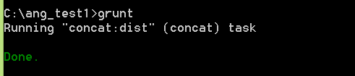

To check if grunt is installed type *grunt –version*

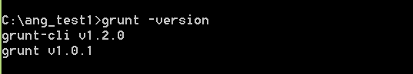

**Step 8** : Install Bower

To install bower run

*npm install bower*

on command prompt

To check the version run   
 *bower –version*

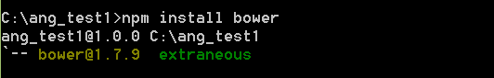

**Step 9** : Install and Configure MavensMate with Sublime Text3

MavensMate is a powerful open source tool for building Force.com IDE.

1. Open Sublime Text, and open console from View -> Show Console.

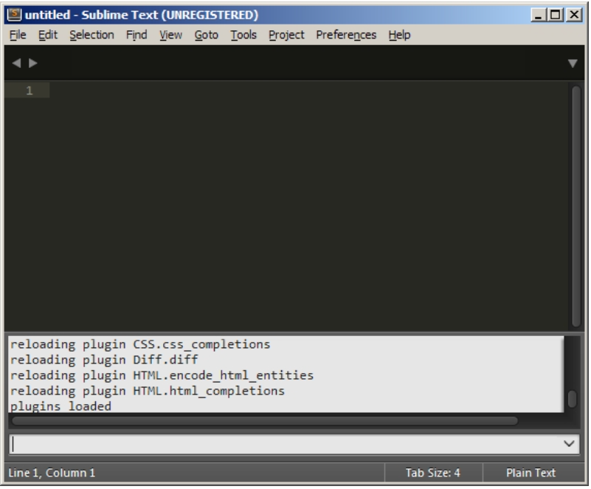

1. Now copy the python code given below and paste it in console.

import urllib.request,os,hashlib; h = '2915d1851351e5ee549c20394736b442' + '8bc59f460fa1548d1514676163dafc88'; pf = 'Package Control.sublime-package'; ipp = sublime.installed_packages_path(); urllib.request.install_opener( urllib.request.build_opener( urllib.request.ProxyHandler()) ); by = urllib.request.urlopen( 'http://packagecontrol.io/' + pf.replace(' ', '%20')).read(); dh = hashlib.sha256(by).hexdigest(); print('Error validating download (got %s instead of %s), please try manual install' % (dh, h)) if dh != h else open(os.path.join( ipp, pf), 'wb' ).write(by)

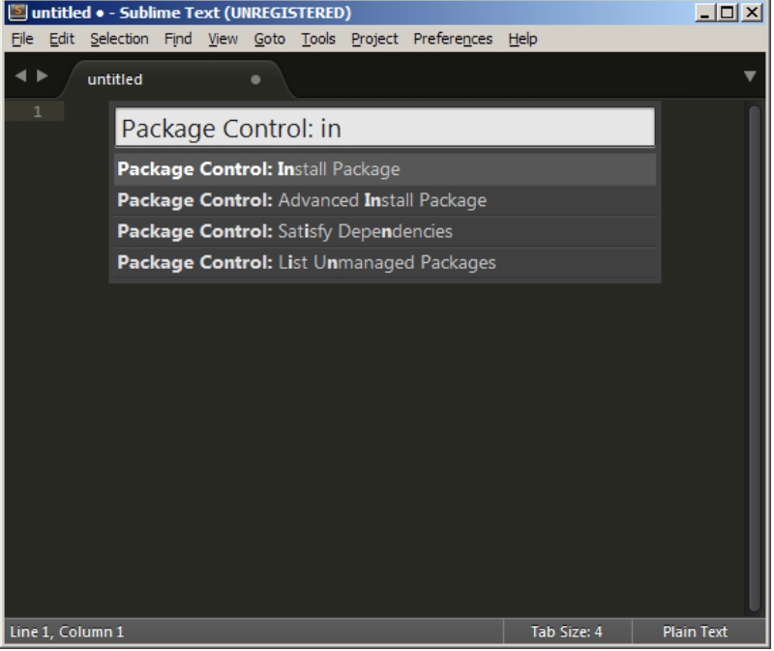

1. You may need to restart Sublime Text for completing the installation.

Now go to Preferences->Package Control

1. Enter Install Package and select it.

               Search for MavensMate and hit Enter.

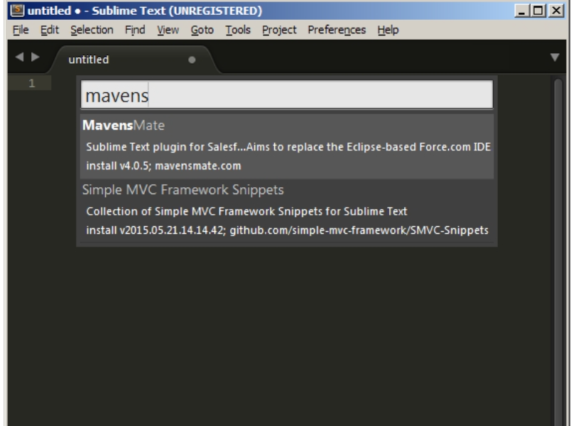

1. For Creating a New Project

-Open MavensMate -> Settings -> User and search for mm_workspace.

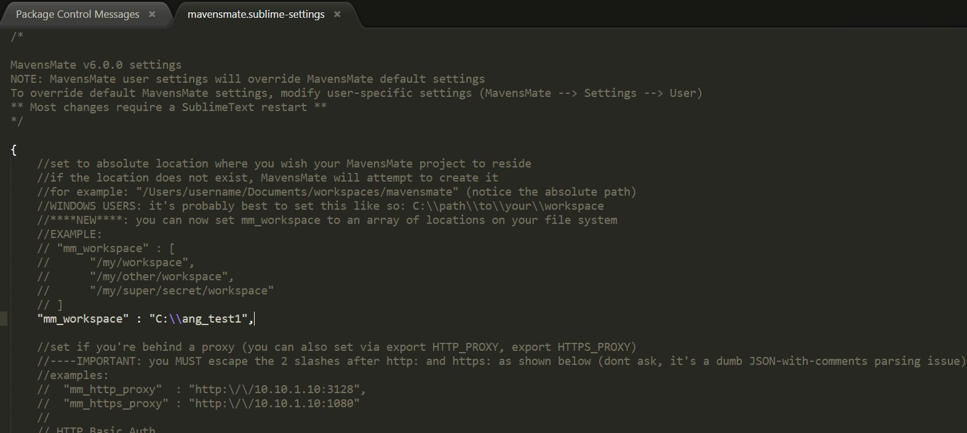-Enter the absolute path of your workspace folder where all the project files will get stored.

-Now we can create our project by going to MavensMate -> Project -> New Project.

1. 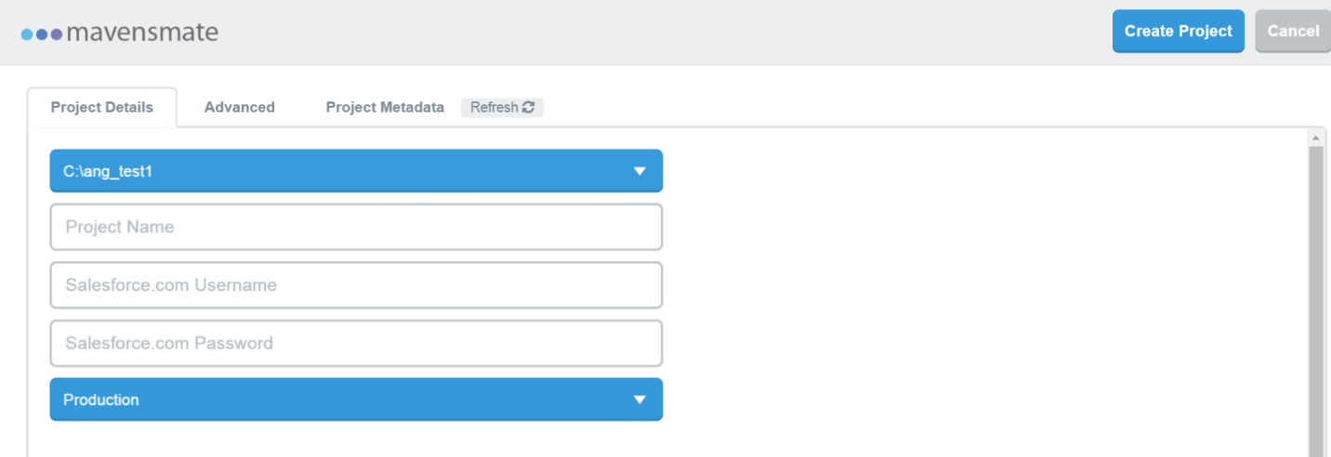A browser window will open where Salesforce credentials need to be specified.
2. The Advanced tab allows one to customize the metadata subscription list and the Project Metadata tab allows one to choose the components to be downloaded. Choose the preferences and click Create Project.
3. MavensMate will download the specified metadata components from the salesforce org. After completing this process, the project will load in Sublime